Exp1:-
Title of the program:-
Write a program to compute ^{n}C_{r} where n= total number of element & r= number of element selected at random.
Program instruction:-
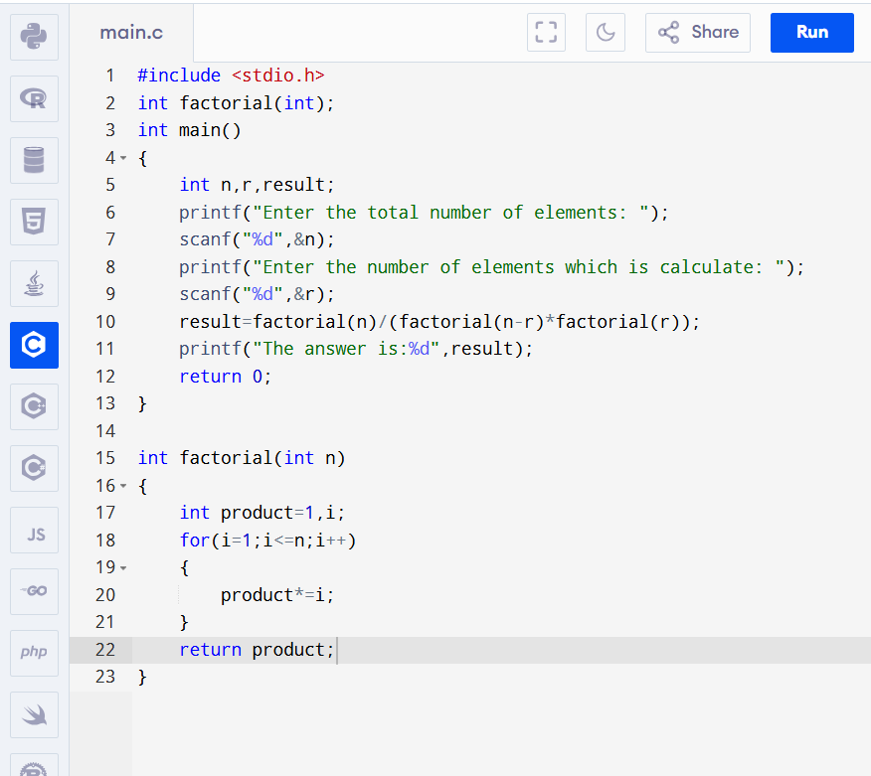
Output:-

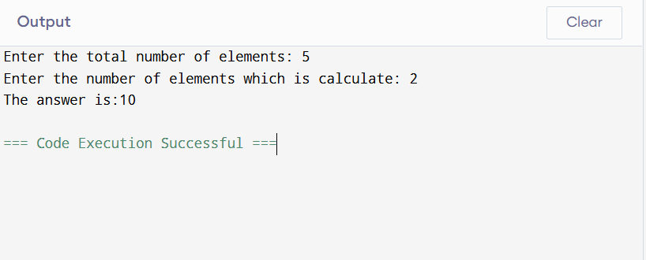
Exp2:-
Title of the program:-
Write a program to compute the diagonal elements of a 4 X 4 matrix.
Program instruction:-
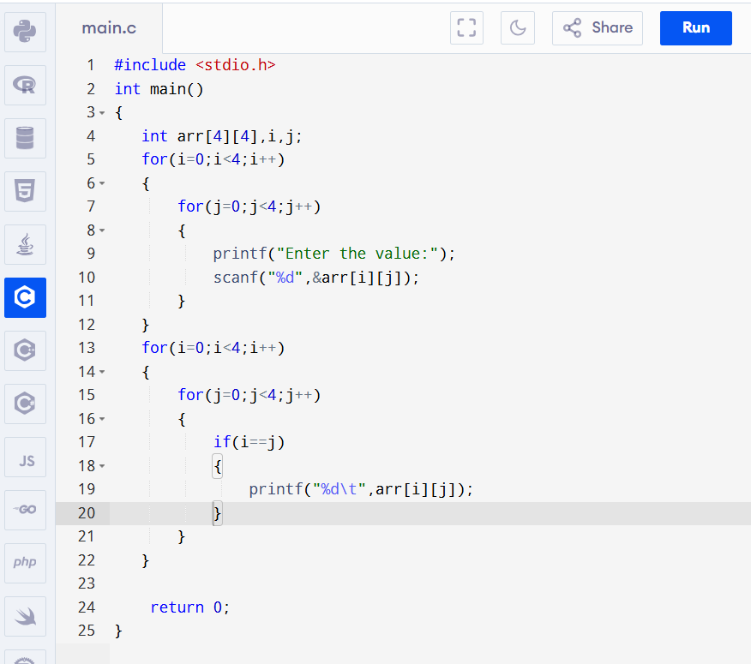
Output:-

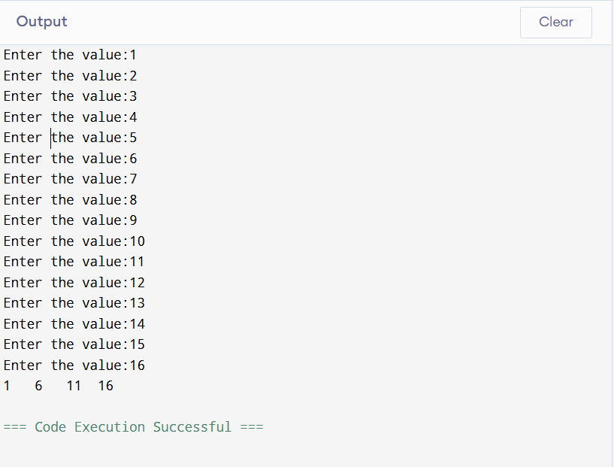
Exp3:-
Title of the program:-
Write a program to compute the square root of a number A using the formula $x_{n+1}$= $\frac{1}{2}{(x}_{n}$+$\frac{A}{x_{n}})$ using iteration where A= number whose square root is computed.
Program instruction:-
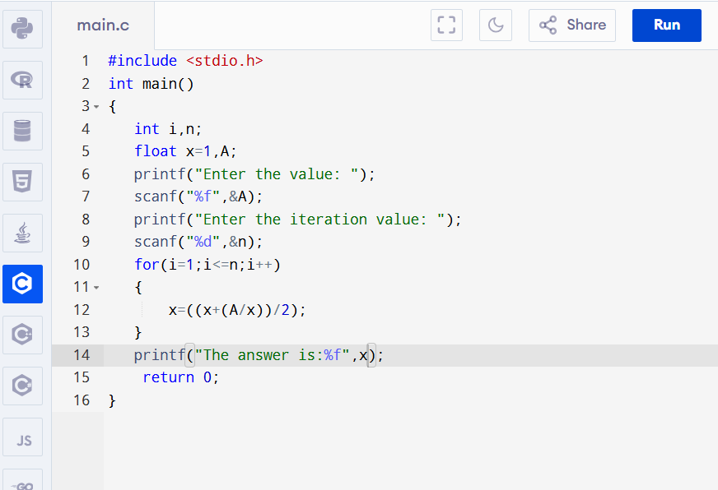
Output:-
